Firebase with Flutter

Intro :
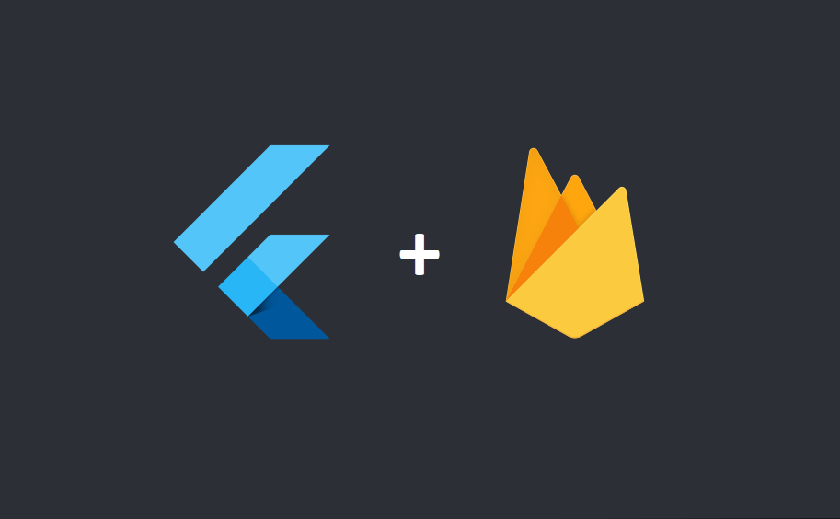
💡 What is this course about?
This course is your gateway to building powerful apps using
👉 Flutter — Google’s UI toolkit for beautiful cross-platform apps
✨ Firebase — Google’s cloud platform for your app’s backend
Together, they make app development faster, easier, and smarter 💪

🔥 What You’ll Learn
✅ Connect your Flutter app to Firebase
✅ Build user Authentication (Signup / Login / Logout)
✅ Store & fetch data with Cloud Firestore
✅ Upload and display images using Firebase Storage
✅ Send Push Notifications to your users
✅ Understand real-time updates and cloud integration
🧩 What You’ll Build
- 🔑 Login & Signup System
- 💬 Real-time Chat App
- 📸 Photo Upload App
- 🔔 Push Notification Demo
🎯 Goal
By the end of this course, you’ll know how to:
Design, develop, and deploy full Flutter apps powered by Firebase — like a pro developer.

Firebase Project Setup
Go to firbase console in chrome
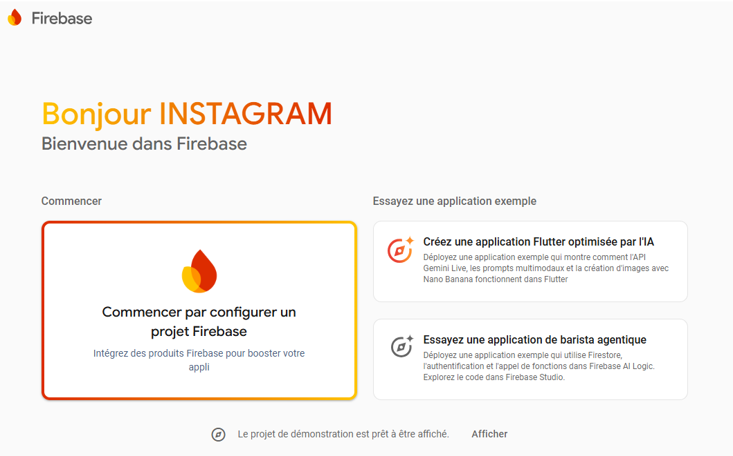

Press on “Commencer par configurer un projet Firebase »
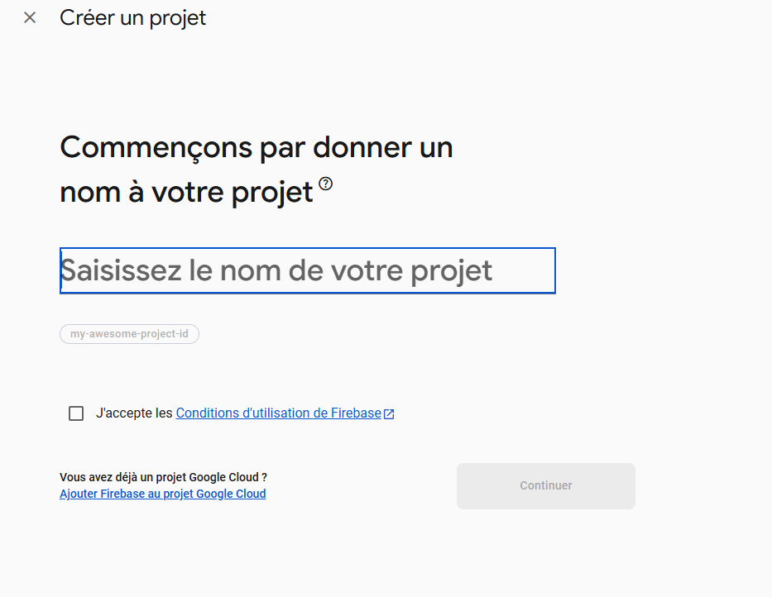

Now we will create our Project , wait for some seconds , and here you are , you have created you first project .
If you re enter now firebase you will se you project there :
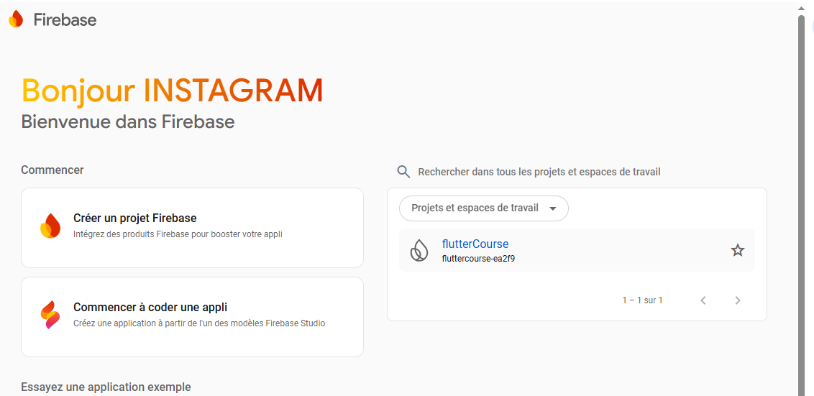
I think now no need to picture , okay go now and create you application :
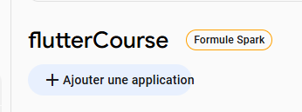
After pressing “Create An Application “ , now please fill some important infos :
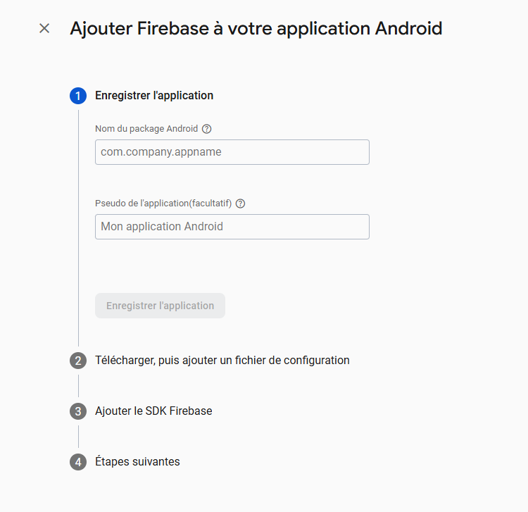
First fill “Android Package Name” :
Your package name usually corresponds to the applicationId value found in the build.gradle file at the application level
You will find it in Android<app<build.gradle.kts
plugins {
id("com.android.application")
Next : enter this manual to see some important info : https://firebase.flutter.dev/docs/manual-installation/android
When creating a new Android app "debug signing certificate SHA-1" is optional, however, it is required for Dynamic Links & Phone Authentication. To generate a certificate run cd android && ./gradlew signingReport and copy the SHA1 from the debug key. This generates two variant keys. You can copy the 'SHA1' that belongs to the debugAndroidTest variant key option.
And this was the response :
PS E:\COURSES\Mobile\flutter\project\flutter_application_1\android> ./gradlew signingReport
Starting a Gradle Daemon, 1 busy and 1 incompatible and 1 stopped Daemons could not be reused, use --status for details
Configuration on demand is an incubating feature.

> Configure project :app
WARNING: The option 'android.enableAapt2' is deprecated.
The current default is 'true'.
It has been removed from the current version of the Android Gradle plugin.
This property has no effect, AAPT2 is now always used.

> Task :flutter_plugin_android_lifecycle:signingReport
Variant: debugAndroidTest
Config: debug
Store: C:\Users\Bilal\.android\debug.keystore
Alias: AndroidDebugKey
MD5: 1F:2F:D0:4F:C1:FC:67:E4:C4:BD:A1:E6:CF:D8:30:DF
SHA1: 26:85:43:3A:AB:A8:3A:6C:BD:89:B2:F4:45:50:CE:14:F6:A5:5B:13
SHA-256: C6:7D:0A:FF:CC:05:FB:F3:11:C9:4E:1F:D7:EF:17:15:97:17:D7:A5:D0:8B:81:A3:D6:13:03:44:0A:8F:19:24
Valid until: Wednesday, August 25, 2055
----------

> Task :geolocator_android:signingReport
Variant: debugAndroidTest
Config: debug
Store: C:\Users\Bilal\.android\debug.keystore
Alias: AndroidDebugKey
MD5: 1F:2F:D0:4F:C1:FC:67:E4:C4:BD:A1:E6:CF:D8:30:DF
SHA1: 26:85:43:3A:AB:A8:3A:6C:BD:89:B2:F4:45:50:CE:14:F6:A5:5B:13
SHA-256: C6:7D:0A:FF:CC:05:FB:F3:11:C9:4E:1F:D7:EF:17:15:97:17:D7:A5:D0:8B:81:A3:D6:13:03:44:0A:8F:19:24
Valid until: Wednesday, August 25, 2055
----------
> Task :google_maps_flutter_android:signingReport
Variant: debugAndroidTest
Config: debug
Store: C:\Users\Bilal\.android\debug.keystore
Alias: AndroidDebugKey
MD5: 1F:2F:D0:4F:C1:FC:67:E4:C4:BD:A1:E6:CF:D8:30:DF
SHA1: 26:85:43:3A:AB:A8:3A:6C:BD:89:B2:F4:45:50:CE:14:F6:A5:5B:13
SHA-256: C6:7D:0A:FF:CC:05:FB:F3:11:C9:4E:1F:D7:EF:17:15:97:17:D7:A5:D0:8B:81:A3:D6:13:03:44:0A:8F:19:24
Valid until: Wednesday, August 25, 2055
----------
> Task :package_info_plus:signingReport
Variant: debugAndroidTest
Config: debug
Store: C:\Users\Bilal\.android\debug.keystore
Alias: AndroidDebugKey
MD5: 1F:2F:D0:4F:C1:FC:67:E4:C4:BD:A1:E6:CF:D8:30:DF
SHA1: 26:85:43:3A:AB:A8:3A:6C:BD:89:B2:F4:45:50:CE:14:F6:A5:5B:13
SHA-256: C6:7D:0A:FF:CC:05:FB:F3:11:C9:4E:1F:D7:EF:17:15:97:17:D7:A5:D0:8B:81:A3:D6:13:03:44:0A:8F:19:24
Valid until: Wednesday, August 25, 2055
----------
> Task :shared_preferences_android:signingReport
Variant: debugAndroidTest
Config: debug
Store: C:\Users\Bilal\.android\debug.keystore
Alias: AndroidDebugKey
MD5: 1F:2F:D0:4F:C1:FC:67:E4:C4:BD:A1:E6:CF:D8:30:DF
SHA1: 26:85:43:3A:AB:A8:3A:6C:BD:89:B2:F4:45:50:CE:14:F6:A5:5B:13
SHA-256: C6:7D:0A:FF:CC:05:FB:F3:11:C9:4E:1F:D7:EF:17:15:97:17:D7:A5:D0:8B:81:A3:D6:13:03:44:0A:8F:19:24
Valid until: Wednesday, August 25, 2055
----------
> Task :url_launcher_android:signingReport
Variant: debugAndroidTest
Config: debug
Store: C:\Users\Bilal\.android\debug.keystore
Alias: AndroidDebugKey
MD5: 1F:2F:D0:4F:C1:FC:67:E4:C4:BD:A1:E6:CF:D8:30:DF
SHA1: 26:85:43:3A:AB:A8:3A:6C:BD:89:B2:F4:45:50:CE:14:F6:A5:5B:13
SHA-256: C6:7D:0A:FF:CC:05:FB:F3:11:C9:4E:1F:D7:EF:17:15:97:17:D7:A5:D0:8B:81:A3:D6:13:03:44:0A:8F:19:24
Valid until: Wednesday, August 25, 2055
----------

> Task :app:signingReport
Variant: debug
Config: debug
Store: C:\Users\Bilal\.android\debug.keystore
Alias: AndroidDebugKey
MD5: 1F:2F:D0:4F:C1:FC:67:E4:C4:BD:A1:E6:CF:D8:30:DF
SHA1: 26:85:43:3A:AB:A8:3A:6C:BD:89:B2:F4:45:50:CE:14:F6:A5:5B:13
SHA-256: C6:7D:0A:FF:CC:05:FB:F3:11:C9:4E:1F:D7:EF:17:15:97:17:D7:A5:D0:8B:81:A3:D6:13:03:44:0A:8F:19:24
Valid until: Wednesday, August 25, 2055
----------
Variant: release
Config: debug
Store: C:\Users\Bilal\.android\debug.keystore
Alias: AndroidDebugKey
MD5: 1F:2F:D0:4F:C1:FC:67:E4:C4:BD:A1:E6:CF:D8:30:DF
SHA1: 26:85:43:3A:AB:A8:3A:6C:BD:89:B2:F4:45:50:CE:14:F6:A5:5B:13
SHA-256: C6:7D:0A:FF:CC:05:FB:F3:11:C9:4E:1F:D7:EF:17:15:97:17:D7:A5:D0:8B:81:A3:D6:13:03:44:0A:8F:19:24
Valid until: Wednesday, August 25, 2055
----------
Variant: profile
Config: debug
Store: C:\Users\Bilal\.android\debug.keystore
Alias: AndroidDebugKey
MD5: 1F:2F:D0:4F:C1:FC:67:E4:C4:BD:A1:E6:CF:D8:30:DF
SHA1: 26:85:43:3A:AB:A8:3A:6C:BD:89:B2:F4:45:50:CE:14:F6:A5:5B:13
SHA-256: C6:7D:0A:FF:CC:05:FB:F3:11:C9:4E:1F:D7:EF:17:15:97:17:D7:A5:D0:8B:81:A3:D6:13:03:44:0A:8F:19:24
Valid until: Wednesday, August 25, 2055
----------
Variant: debugAndroidTest
Config: debug
Store: C:\Users\Bilal\.android\debug.keystore
Alias: AndroidDebugKey
MD5: 1F:2F:D0:4F:C1:FC:67:E4:C4:BD:A1:E6:CF:D8:30:DF
SHA1: 26:85:43:3A:AB:A8:3A:6C:BD:89:B2:F4:45:50:CE:14:F6:A5:5B:13
SHA-256: C6:7D:0A:FF:CC:05:FB:F3:11:C9:4E:1F:D7:EF:17:15:97:17:D7:A5:D0:8B:81:A3:D6:13:03:44:0A:8F:19:24
Valid until: Wednesday, August 25, 2055
----------

BUILD SUCCESSFUL in 2m 4s
11 actionable tasks: 7 executed, 4 up-to-date
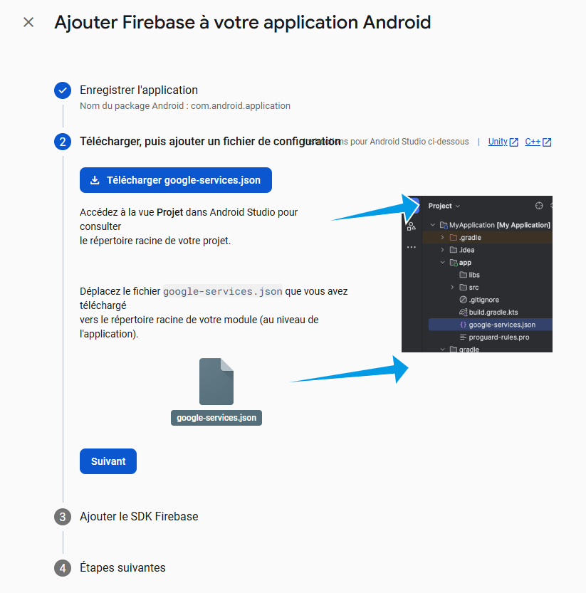

Please just follow the step they are sooo easy :
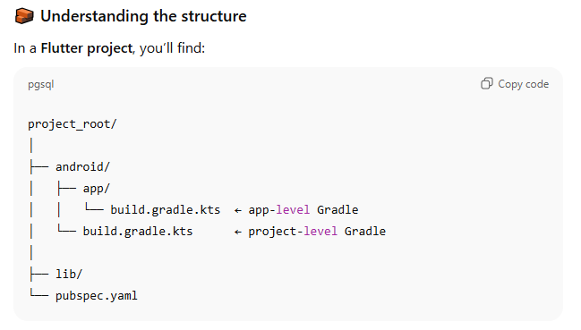

This well help you in sdk
In genral , I will copy/paste my files to you :
1️⃣ What are .kts files?
- .kts = Kotlin Script version of Gradle.
- .gradle = Groovy version (older style).
- They do the same thing — just different syntax.
For example:
Groovy style:
plugins {
id 'com.android.application'
id 'com.google.gms.google-services'
}
Kotlin .kts style:
plugins {
id("com.android.application")
id("com.google.gms.google-services")
}
2️⃣ Why Flutter uses .kts
- Flutter templates for Android now generate Kotlin DSL (.kts) by default.
- This is modern Gradle style and works better with Flutter + Kotlin plugins.
- Firebase docs are written for pure Android Groovy projects, which is why you see differences.

Files
1️⃣ Final project-level Gradle (android/build.gradle.kts)
// 🔹 Add the Firebase plugin (apply false here)
// This is required so that your app module can apply it later
plugins {
id("com.google.gms.google-services") version "4.4.4" apply false
}

// 🔹 Repositories for all projects (where Gradle looks for dependencies)
allprojects {
repositories {
google() // Google's Maven repository (Firebase lives here)
mavenCentral() // Maven Central repository
}
}

// 🔹 Change the build directory to a custom location
val newBuildDir: Directory =
rootProject.layout.buildDirectory
.dir("../../build") // "../../build" is relative to the root
.get()
rootProject.layout.buildDirectory.value(newBuildDir)

// 🔹 Set up each subproject to have its own build directory
subprojects {
val newSubprojectBuildDir: Directory = newBuildDir.dir(project.name)
project.layout.buildDirectory.value(newSubprojectBuildDir)
}

// 🔹 Make sure the app module is evaluated before others
subprojects {
project.evaluationDependsOn(":app")
}

// 🔹 Clean task (runs when you do `./gradlew clean` or `flutter clean`)
tasks.register<Delete>("clean") {
delete(rootProject.layout.buildDirectory)
}

2️⃣ Explanation / How to read it
- plugins { ... }
  - Adds Google services plugin for Firebase.
  - apply false = don’t apply it here; it will be applied in the app-level Gradle.
- allprojects { repositories { ... } }
  - Tells Gradle where to find dependencies (Firebase, Android Gradle plugin, etc.).
- val newBuildDir + rootProject.layout.buildDirectory.value(newBuildDir)
  - Changes the build folder location.
  - Useful for keeping build outputs separate or for CI/CD.
- subprojects { ... }
  - Each module/subproject (like :app) gets its own build directory inside newBuildDir.
  - Ensures no conflicts and organizes build artifacts.
- project.evaluationDependsOn(":app")
  - Makes sure the :app module is evaluated first before others.
  - Important if other modules depend on app module’s configuration.
- tasks.register<Delete>("clean") { ... }
  - Defines a clean task.
  - Deletes the entire build directory when running flutter clean or ./gradlew clean.
✅ Key point:
- This project-level Gradle does not contain dependencies for Firebase SDKs.
- All Firebase SDKs go in the app-level Gradle (android/app/build.gradle.kts).
- This file mainly sets up plugin availability, repositories, and build directory rules.
app-level Gradle (android/app/build.gradle.kts)
plugins {
id("com.android.application")
id("kotlin-android")
id("dev.flutter.flutter-gradle-plugin")

// Apply Firebase plugin here
id("com.google.gms.google-services")
}

android {
namespace = "com.example.flutter_application_1"
compileSdk = flutter.compileSdkVersion
ndkVersion = flutter.ndkVersion

compileOptions {
sourceCompatibility = JavaVersion.VERSION_11
targetCompatibility = JavaVersion.VERSION_11
}

kotlinOptions {
jvmTarget = JavaVersion.VERSION_11.toString()
}

defaultConfig {
applicationId = "com.example.flutter_application_1"
minSdk = flutter.minSdkVersion
targetSdk = flutter.targetSdkVersion
versionCode = flutter.versionCode
versionName = flutter.versionName
}

buildTypes {
release {
signingConfig = signingConfigs.getByName("debug")
}
}
}

flutter {
source = "../.."
}

dependencies {
// Firebase BoM
implementation(platform("com.google.firebase:firebase-bom:34.4.0"))
implementation("com.google.firebase:firebase-analytics")
}
🔹 Key points
- No apply plugin: in .kts.
- Firebase plugin is added inside plugins { ... }.
- Dependencies for Firebase go into the dependencies { ... } block.
- Everything else (android {} and flutter {}) stays the same.

Initialization
Now we will see all importants packages :
- Firebase_core https://pub.dev/packages/firebase_core
- Cloud_firestore : https://pub.dev/packages/cloud_firestore
- Firebase_storage : https://pub.dev/packages/firebase_storage
- Firebase_messaging : https://pub.dev/packages/firebase_messaging
- Firebase_auth : https://pub.dev/packages/firebase_auth
- Google_sign_in : https://pub.dev/packages/google_sign_in

So :
# Firebase packages
firebase_core: ^4.2.0
firebase_messaging: ^16.0.3
firebase_storage: ^13.0.3
cloud_firestore: ^6.0.3
firebase_auth: ^6.1.1
google_sign_in: ^7.2.0

Finnaly , we haved ended the most hard thing (for me ), now let’s get started ,
Bref this is the main file , because you have to add a function in main func:
import 'package:firebase_core/firebase_core.dart';
import 'package:flutter/material.dart';
import 'home.dart';

void main() async {
WidgetsFlutterBinding.ensureInitialized();
await Firebase.initializeApp();

runApp(const MyApp()); // Add const
}

class MyApp extends StatelessWidget {
const MyApp({super.key}); // Keep const here

@override
Widget build(BuildContext context) {
return MaterialApp(
debugShowCheckedModeBanner: false,
title: "Flutter Web Demos",
theme: ThemeData(primarySwatch: Colors.blue),
home: const HomePage(), // Add const
routes: {
'/home': (context) => const HomePage(), // Add const
},
);
}
}

As you see I added two simple lines :
WidgetsFlutterBinding.ensureInitialized();
await Firebase.initializeApp();

• First line → ensures Flutter is ready for async operations.
• Second line → connects your app to Firebase so you can use Firebase features.

Login Ui
Now we will build an ui that we will use it to practice what we will learn inshallah :
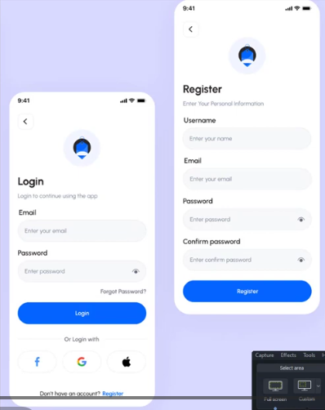
As you see, it’s so simple, and now let’s start coding it :

Create you files and starts :
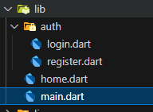
I finish the ui :
Here is the link for github all project :

Platform Firebase App Id
web 1:475068962100:web:8b93ae01e437587cb58161
android 1:475068962100:android:6509280302dd20beb58161
ios 1:475068962100:ios:888dab6ac4a47ea5b58161
macos 1:475068962100:ios:888dab6ac4a47ea5b58161
windows 1:475068962100:web:aea507065beff0e6b58161

FlutterFire CLI

🧠 What is a CLI?
CLI means Command Line Interface.
It’s a tool you use by typing commands in a terminal instead of clicking buttons in a window.
Think of it like:
A “remote control” for your tools — but using text commands instead of mouse clicks.

What is the FlutterFire CLI?
The FlutterFire CLI is a special command-line tool made by Firebase and Flutter teams.
It helps you connect your Flutter app to Firebase automatically.
Without it, you would have to:
- Manually go to the Firebase Console
- Manually download and copy google-services.json,
- Manually add Gradle settings,
- Manually create your Firebase options…
😩 That’s a lot.
With FlutterFire CLI, you just run one command:
flutterfire configure
and it:
✅ Connects your project to Firebase
✅ Registers your Android, iOS, Web, and Windows apps
✅ Creates the firebase_options.dart file
✅ Configures everything automatically

Tool | Full Name | Purpose
Firebase CLI | Firebase Command Line Interface | Manages Firebase projects (login, deploy, etc.)
FlutterFire CLI | Flutter + Firebase Command Line Interface | Connects your Flutter app to your Firebase project automatically
💬 Example analogy:
Think of Firebase as a big house (your backend).
The FlutterFire CLI is the key that tells your Flutter app which house to connect to and how to open the door.

Install CLI
Step 1: Activate FlutterFire CLI via Dart
dart pub global activate flutterfire_cli
- This downloads FlutterFire CLI and installs it globally.
- After installation, the executable is located at:
- C:\Users\Bilal\AppData\Local\Pub\Cache\bin

Step 2: Check the installed global Dart packages
dart pub global list
- You should see:
flutterfire_cli 1.3.1
- This confirms the CLI is installed.

Step 3: Add FlutterFire CLI to PATH
- Open Environment Variables → search “Edit environment variables for your account” in Windows.
- Under User variables → Path → Edit → New, paste:
C:\Users\Bilal\AppData\Local\Pub\Cache\bin
- Click OK to save, then close and reopen your terminal.
- Test:
flutterfire --version
- Should display a version like 1.3.1.

Step 4: Install Firebase CLI (dependency)
npm install -g firebase-tools
- You need Node.js and npm installed first.
- Check installation:
firebase --version
- Should display a version number, e.g., 13.x.x.

Step 5: Log in to Firebase
firebase login
- Opens a browser → sign in with your Firebase account.

Step 6: Configure your Flutter project
flutterfire configure
- Prompts:
  - Select a Firebase project (or create a new one)
  - Select platforms (Android, iOS, Web, Windows, macOS)
- Generates:
lib/firebase_options.dart

FirebaseAuth email password
So after Connecting so Firebase using CLI , you are ready 100% for this parti
Enter Authentifation in firebase console :
Pls just follow images :

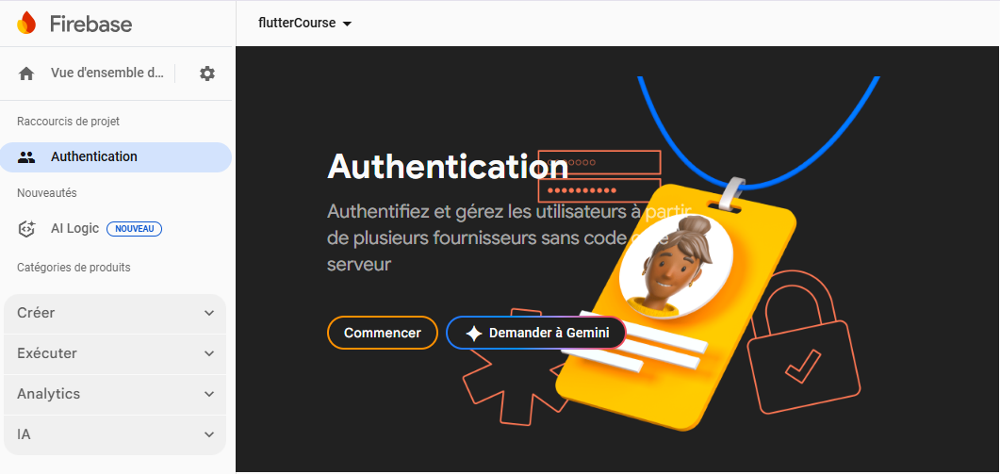

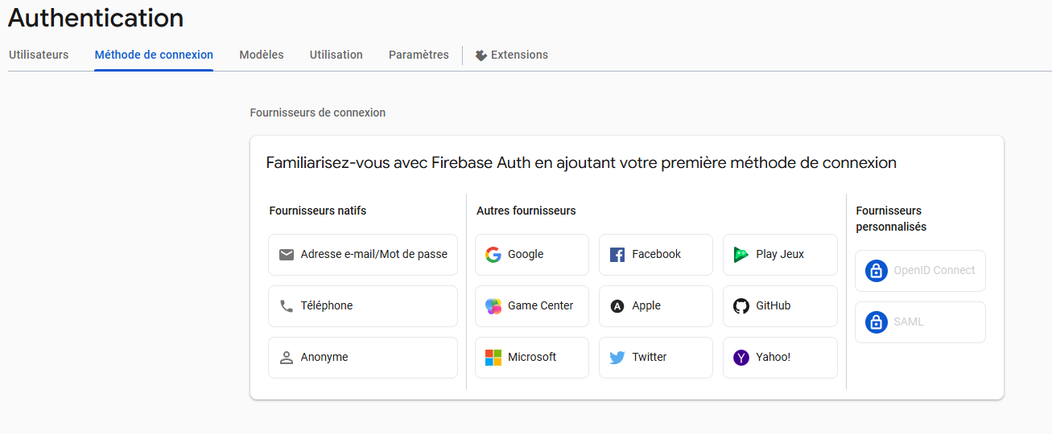

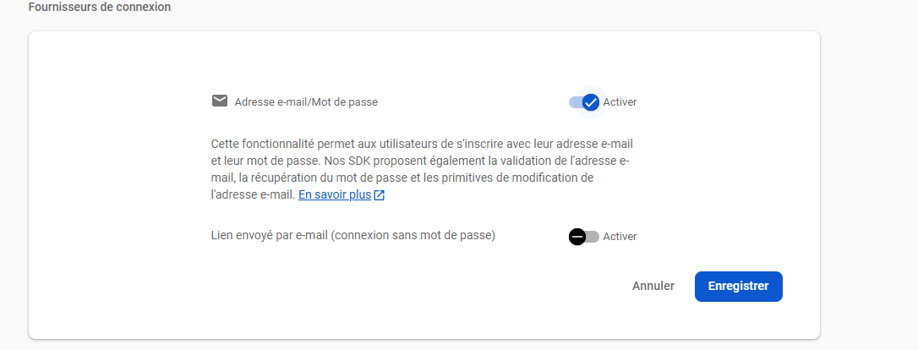
Now you have make it “active” :
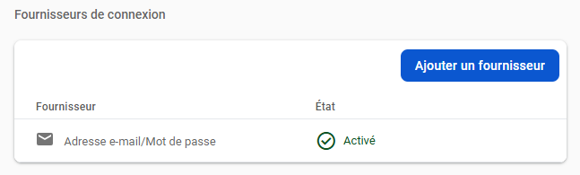
Note : Every stream should be in main file :

authStateChanges()
1️⃣ What is authStateChanges()?
authStateChanges() is a stream provided by Firebase Auth that notifies your app whenever the user's authentication state changes.
Changes include:
- User signs in
- User signs out
- User is updated (like email verification)
It returns a Stream<User?>:
- User → A signed-in user
- null → No user is signed in

initState() {
FirebaseAuth.instance.authStateChanges().listen((User? user) {
if (user == null) {
print('========== User is currently signed out!');
print(user);
} else {
print('========== User is signed in!');
print(user);
}
});

super.initState();
}

For now this is the result:
========== User is currently signed out!
null

to login , we have first to register,
so read this : https://firebase.flutter.dev/docs/auth/password-auth

Creating a Password-Based Account with Firebase in Flutter
Firebase Authentication makes it easy to handle user registration, login, and authentication in your Flutter app. One of the most common methods is email and password sign-up.

1️⃣ Creating a New User
To create a new account, Firebase provides the method:
mainButton(
text: "Register",
onPressed: () async {
if (passwordController.text != confirmPasswordController.text) {
print("Passwords don't match");
return;
}
try {
final credential = await FirebaseAuth.instance
.createUserWithEmailAndPassword(
email: emailController.text,
password: passwordController.text,
);
} on FirebaseAuthException catch (e) {
if (e.code == 'weak-password') {
print("The password provided is too weak.");
} else if (e.code == 'email-already-in-use') {
print("The account already exists for that email.");
}
} catch (e) {
print(e);
}
},
),

Example of “e” returned :
[firebase_auth/weak-password] Password should be at least 6 characters
The password provided is too weak.

If we do all great :
========== User is signed in!
And we will see our selves there :
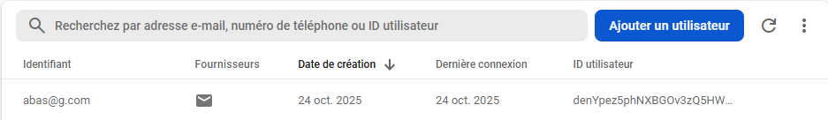
This is how credential looks like :
UserCredential(additionalUserInfo: AdditionalUserInfo(isNewUser: true, profile: {}, providerId: password, username: null, authorizationCode: null), credential: null, user: User(displayName: null, email: bilal@g.cim, isEmailVerified: false, isAnonymous: false, metadata: UserMetadata(creationTime: 2025-10-24 19:55:30.000Z, lastSignInTime: 2025-10-24 19:55:30.000Z), phoneNumber: null, photoURL: null, providerData, [UserInfo(displayName: null, email: bilal@g.cim, phoneNumber: null, photoURL: null, providerId: password, uid: bilal@g.cim)], refreshToken: AMf-vBxbxve2UoUqMuMNj3LZ3YG2JAN9mDTEipl0dYlFNBPeXZcbyp6WZlISZkcnngpi36eRXUbTwMy1vjsXbR6Zy19Sd4uWMLTiiHKQjVwCmza9DfJL6V3Q-fTJr1x1yeuk9F-Ylxjjf543sTuCgP7mK1qf400TtR1DRtVA_luG_77cPrFIw4ArE5yTIFJ1uw3i-mCCiDJ6Jf3Kkdz3HfFpj_WGSUGCWA, tenantId: null, uid: TyDWeRZQ0PfUTaXBAwWKXcppZtu1))

SignOut :
appBar: AppBar(
title: const Text("Home Page"),
actions: [
IconButton(
onPressed: () async {
await FirebaseAuth.instance.signOut();
Navigator.pushNamedAndRemoveUntil(context, 'login', (_) => false);
},
icon: const Icon(Icons.logout),
),
],
),
1️⃣ What it is
FirebaseAuth.instance.signOut() is a method provided by Firebase Authentication to log out the currently signed-in user.
- FirebaseAuth.instance → The singleton instance of Firebase Authentication in your app.
- signOut() → Performs the action of signing out the user.
- await → Since signing out is an asynchronous operation, you must await it inside an async function to ensure it completes before running the next code.

2️⃣ Key Points
- After calling signOut(), the user is no longer authenticated.
- Any listeners on authStateChanges() will automatically be notified and emit null.
- You can then redirect the user to a login screen or update the UI accordingly.
But now if you make reload, the app directly goes to login page , even if you was sign in , this is the solution :
home: (FirebaseAuth.instance.currentUser != null)
? const HomePage()
: const LoginPage(),

Email Verification
The idea was : when the user login , if the user verifer its email, it well see verified , otherwise he we see a button for verifacation :
(FirebaseAuth.instance.currentUser!.emailVerified)
? const Center(child: Text("Verified"))
: Center(
child: MaterialButton(
onPressed: () {
FirebaseAuth.instance.currentUser?.sendEmailVerification();
},
color: Colors.amber,
padding: const EdgeInsets.all(15),
textColor: Colors.white,
child: const Text("Verify Your Email"),
),
),

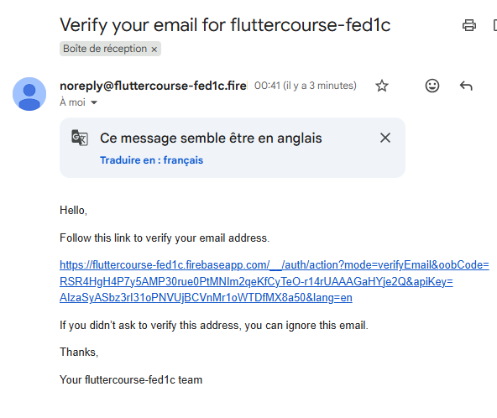
this is example for email received
when you click all that you have to do is :

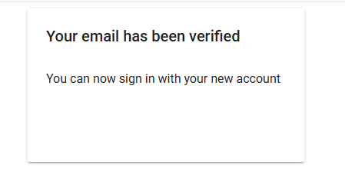

Gooble Sign in
This part exactly , takes me 2 days debugging hhhh, because the functions changes from time to other , and am following wael abo hamza course , so it was the old funciton ,
No problem these are functions :
final GoogleSignIn googleSignIn = GoogleSignIn(
clientId:
'475068962100-rj1fb14cq1nfi75etlfinv25slhh2706.apps.googleusercontent.com', // remplace par ton Web Client ID complet
scopes: ['email', 'profile'],
signInOption: SignInOption.standard, // important pour Web
);

Future<UserCredential> signInWithGoogle() async {
try {
// Déclenche le flux de connexion
final GoogleSignInAccount? googleUser = await googleSignIn.signIn();

// Si l'utilisateur annule la connexion
if (googleUser == null) {
return Future.error("Login canceled by user");
}

// Récupérer les informations d'authentification
final GoogleSignInAuthentication googleAuth =
await googleUser.authentication;

// Créer les credentials Firebase
final credential = GoogleAuthProvider.credential(
accessToken: googleAuth.accessToken,
idToken: googleAuth.idToken,
);

// Sign in avec Firebase
return await FirebaseAuth.instance.signInWithCredential(credential);
} catch (e) {
if (e.toString().contains('popup_closed')) {
return Future.error('Popup fermée avant authentification');
}
return Future.error('Erreur Google Sign-In: $e');
}
}
Here is how to use it :
InkWell(
onTap: () {
print("google");
signInWithGoogle();
},

For cliend id you will take it from :
https://console.cloud.google.com/apis/credentials?pli=1&project=fluttercourse-fed1c
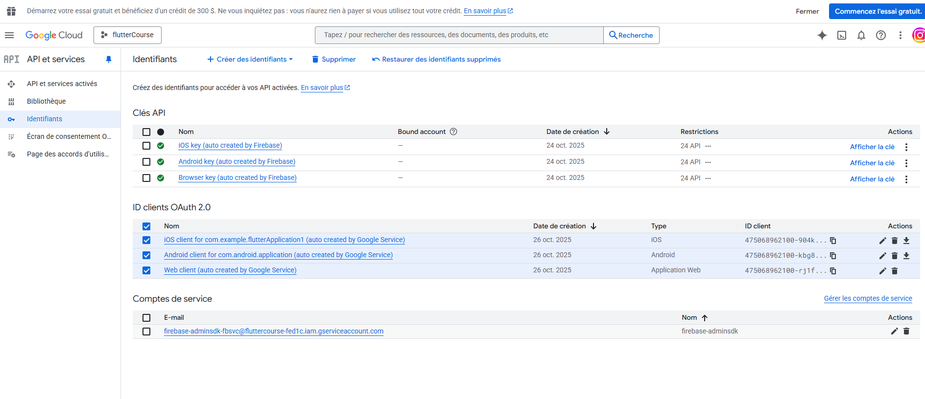

Send a password reset email
To improve security and prevent email enumeration attacks, we avoid revealing whether an email exists in our system. Instead of showing different messages for existing and non-existing emails, we always display a neutral message. This way, attackers cannot determine which emails are registered.

InkWell(
onTap: () async {
final email = emailController.text.trim();
if (email.isEmpty) return;

// send password reset email
await FirebaseAuth.instance.sendPasswordResetEmail(
email: email,
);
// show snackbar
final snackBar = SnackBar(
elevation: 0,
behavior: SnackBarBehavior.floating,
backgroundColor: Colors.transparent,
content: AwesomeSnackbarContent(
title: 'Info',
message: 'If the email exists, you will receive an email',
contentType: ContentType.help,
),
);
ScaffoldMessenger.of(context).showSnackBar(snackBar);
},
child: Text(
"Forgot Password?",
style: TextStyle(fontSize: 12),
textAlign: TextAlign.right,
),
),

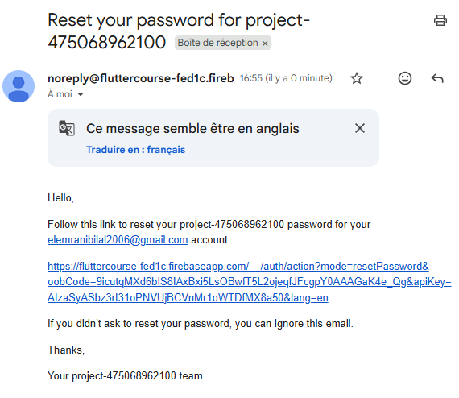

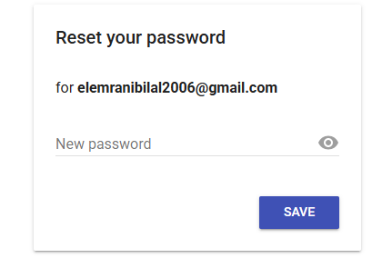

Firestore

🔥 What is Firestore?
Firestore (also called Cloud Firestore) is a database made by Google and part of Firebase.
It helps you store and manage data for your apps (mobile, web, or backend) — without needing to manage your own servers.

🧠 Think of it like:
📱 Your app ↔️ Firestore (on Google’s servers)
Instead of saving data in your phone or your computer, your app sends and receives it from Firestore, which is online and always available.
💾 Example
If you’re making a chat app:
- You can save messages like:
Json
{
"sender": "Bilal",
"message": "Hello!",
"timestamp": "2025-10-29T18:00:00"
}

• Firestore stores that data in the cloud.
• Then any user who opens your app can see it instantly — because Firestore updates in real-time ⚡

🔍 Main Features
Feature | Explanation
NoSQL database | Data is stored as collections (like folders) and documents (like files).
Real-time updates | Your app gets new data instantly when someone changes it.
Offline mode | Works even without internet — syncs automatically when online again.
Secure | You control who can read or write data using security rules.
Scalable | Can handle thousands or millions of users easily.

From chat gpt :
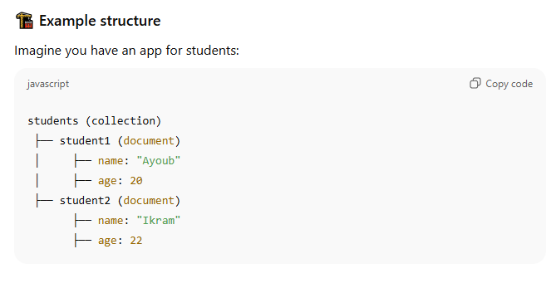

🔧 Used with
Flutter
JavaScript / React / Vue
Android / iOS
Python (admin)

FireStore elements

Collection
- A collection is like a folder 🗂️.
- It contains documents inside it.
- Collections cannot contain other collections directly — only documents.
- Each collection groups related data (like users, products, messages).

Document
- A document is like a file 📄 inside a collection.
- It contains data (key-value pairs, like JSON).
- Each document has a unique ID (you can choose it or let Firestore create it).
- Documents can also contain subcollections inside them.

Subcollection
- A subcollection is a collection inside a document 📁.
- It works exactly like a normal collection but is “nested” inside a specific document.
- Useful when you want to store related data specific to that document (like messages of one user).

Document inside a subcollection
- Each subcollection also contains documents (just like a normal collection).
- Those documents store data related to that subcollection.

🧠 Summary Table

Level | Firestore Element | Acts Like | Contains | Example
1️⃣ | Collection | Folder | Documents | users, products
2️⃣ | Document | File | Data + subcollections | user1
3️⃣ | Subcollection | Folder inside a file | Documents | chats
4️⃣ | Document inside subcollection | File inside subfolder | Data + subcollections | chat_ayoub
5️⃣ | Subcollection inside subcollection | Folder inside folder | Documents | messages

Example from chat gpt :
🏗️ Project Idea: Chat App
We’ll imagine a small chat app called “ChatNow”
Users can register, send messages, and each message belongs to a conversation.
We’ll build its Firestore structure step by step 👇

🔹 Level 1: Collection
We start with a main collection called users — it stores all users of the app.
users (collection)

🔹 Level 2: Document
Each user will be one document inside the users collection.
Example:
users
├── user1
└── user2
Each document has the user’s personal data:
user1
├── name: "Bilal"
├── email: "bilal@example.com"
├── status: "online"

🔹 Level 3: Subcollection
Now, each user can have subcollections — for example, a list of their friends or messages.
Let’s add a subcollection called chats inside each user.
users
└── user1
└── chats (subcollection)

🔹 Level 4: Document inside the subcollection
Inside chats, each document represents one conversation (with another user).
Example:
users
└── user1
└── chats
├── chat_ayoub
└── chat_ikram
Each chat document contains information about that conversation:
chat_ayoub
├── lastMessage: "See you tomorrow!"
├── lastUpdated: 2025-10-29T18:00:00

🔹 Level 5: Subcollection inside that chat
Now, each chat has multiple messages, so we add another subcollection inside each chat document:
users
└── user1
└── chats
└── chat_ayoub
└── messages (subcollection)

🔹 Level 6: Documents inside messages
Each message is a document inside the messages subcollection.
messages
├── msg1
├── msg2
├── msg3
Each message document might look like:
msg1
├── sender: "Bilal"
├── text: "Hey Ayoub!"
├── timestamp: 2025-10-29T18:02:00
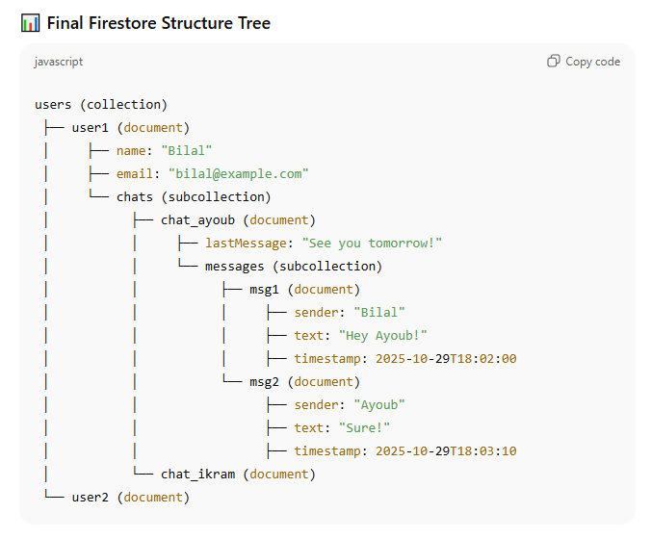

Firestore : add
First create you database , you have just to follow steps, images are soo clear :
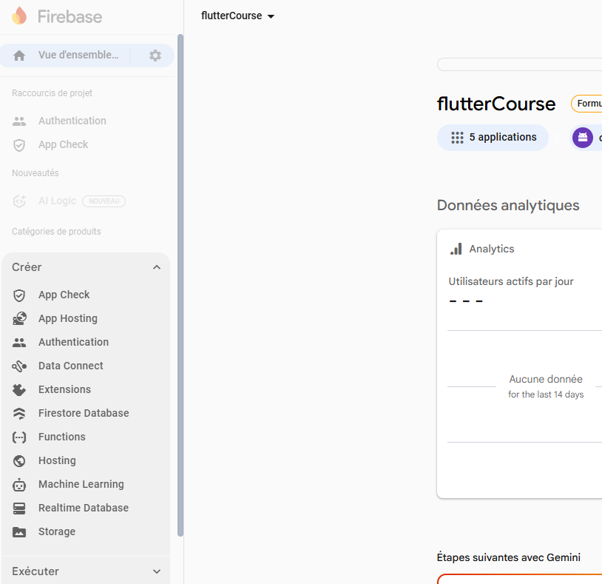

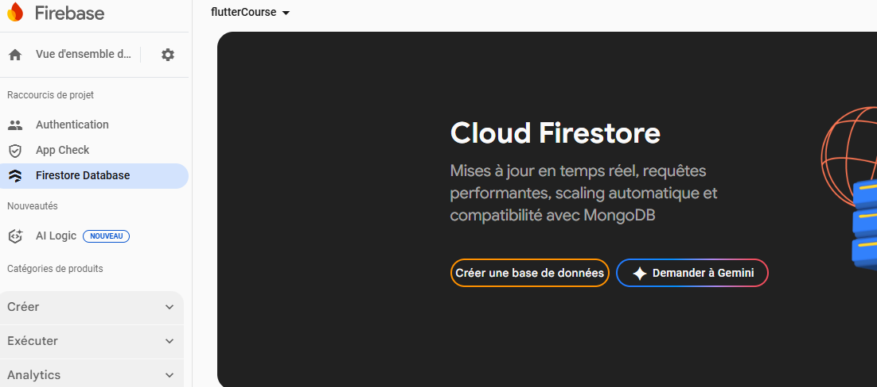

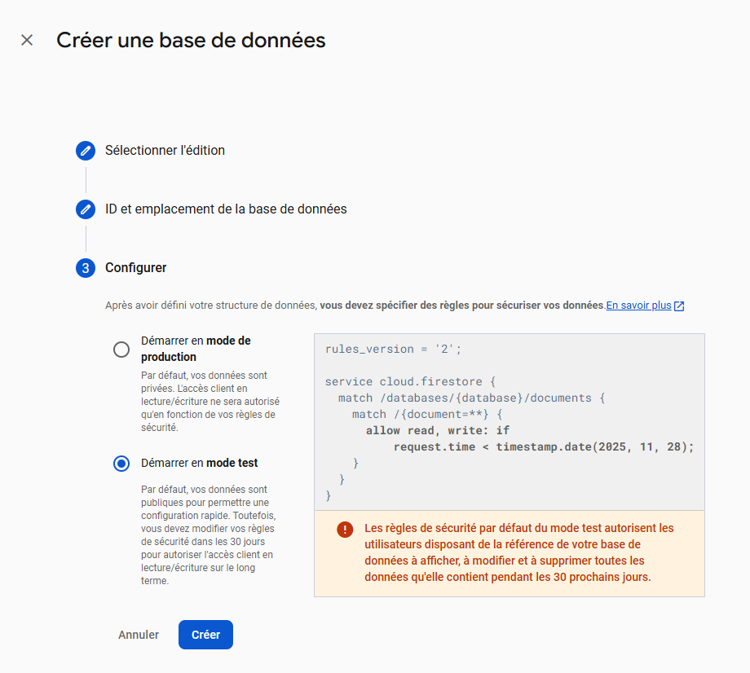
Chat gpt told us the diff :
🟢 Démarrer en mode de production (Production mode)
- Data is private by default.
- No one (even your app) can read or write data unless you define security rules to allow it.
- It’s the safest option for real apps used by real users.
- Example rule (default):
- allow read, write: if false;
→ means “no one can read or write anything until you change the rules.”
✅ Use this for real projects that are already deployed.

🟠 Démarrer en mode test (Test mode)
- All data is public (anyone with your database reference can read/write).
- It’s meant for quick testing and trying out Firestore easily.
- But it expires after 30 days (as shown in the warning).
- Example rule (shown in your image):
- allow read, write: if request.time < timestamp.date(2025, 11, 28);
→ anyone can read/write until that date.
✅ Use this for learning or quick development (like while building and testing your app).
,,
If you see this , it mean you are well done hhh
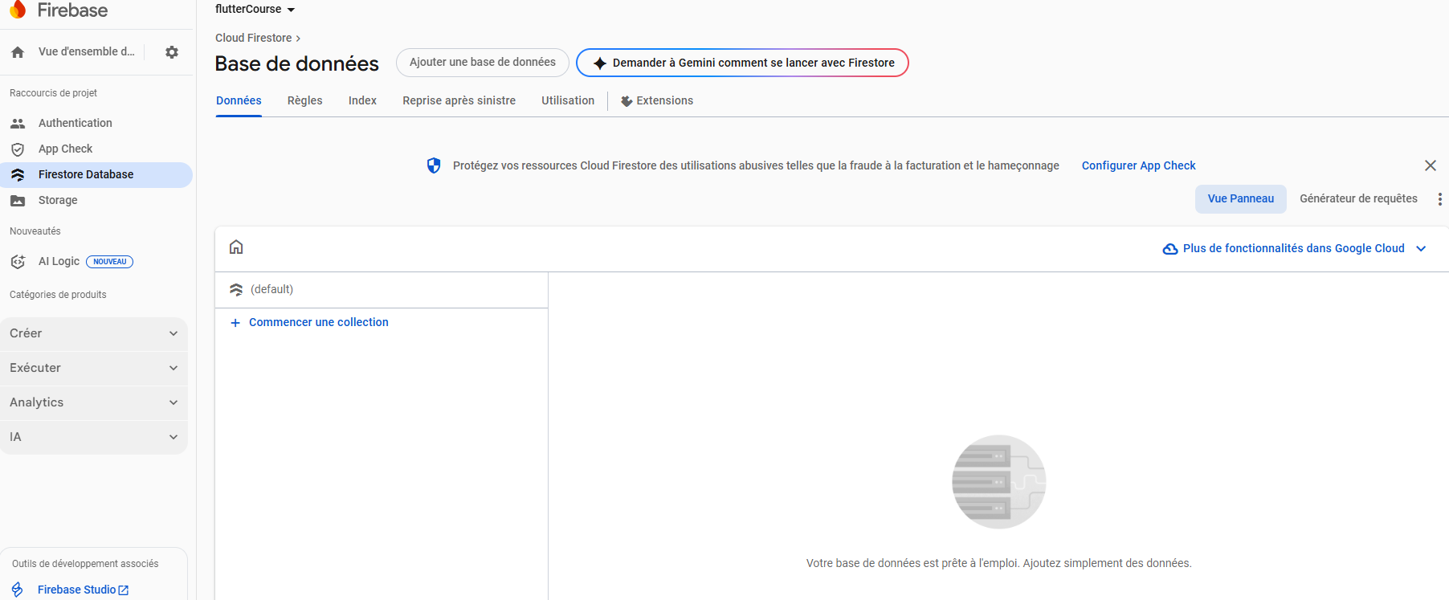

Now let’s pass to code :
// create a collectionRefrence
CollectionReference categories = FirebaseFirestore.instance.collection(
"categories",
);
Future<void> addCategory(String data) {
return categories
.add({'name': data})
.then((value) => print("Category Added"))
.catchError((error) => print(error));
}
It’s soo easy :
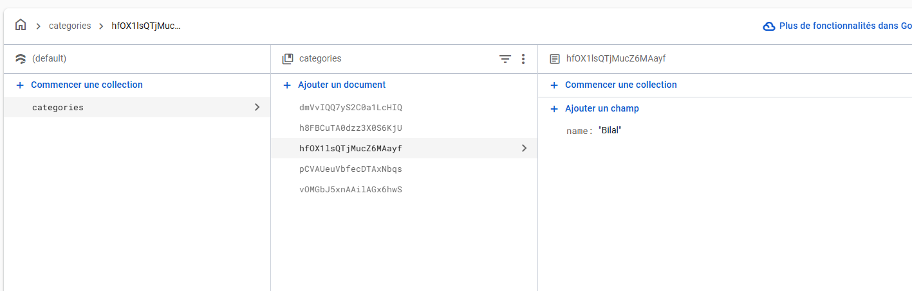
🔹 1️⃣ FirebaseFirestore.instance
- This gives you access to your Firestore database that you created on Firebase.
- Think of it like saying:
👉 “Hey Flutter, connect me to my Firestore database in the cloud.”
📘 Analogy:
It’s like opening the door to your Firestore building — you need this before you can enter and do anything inside (like adding or reading data).

🔹 2️⃣ .collection("categories")
- This means you’re telling Firestore:
👉 “I want to work with a collection (folder) named categories.”
If the collection doesn’t exist yet, Firestore will automatically create it the first time you add data.
📘 Analogy:
Imagine Firestore as a big cabinet.
Each collection is a drawer labeled with a name (categories in this case).

🔹 3️⃣ CollectionReference
CollectionReference categories = ...
- A CollectionReference is a variable that points to a collection in Firestore.
- It gives you access to methods like:
  - .add() → add new documents
  - .doc() → access a specific document
  - .get() → read all documents
📘 Analogy:
It’s like holding the key to open a specific drawer (categories) in your Firestore cabinet.

🔹 4️⃣ The addCategory() function
Future<void> addCategory(String data) { ... }
- This function takes a piece of text (for example "Fruits") and adds it to the database.
- It returns a Future<void> because the operation is asynchronous — it takes some time to finish, since Firestore is online.
📘 Analogy:
You give a request to Firestore — it takes a few moments to save your document in the cloud, then it confirms success or failure.

🔹 5️⃣ .add({'name': data})
- This line creates a new document inside the categories collection.
- The document will contain one field:
- {
- "name": "the value of data"
- }
- Firestore automatically creates a random document ID like:
- categories
- └── Rq23DxLsa7iUQ4
- └── name: "Fruits"
📘 Analogy:
You drop a new paper inside the “categories” drawer — Firestore gives it a random label number.

🔹 6️⃣ .then(...)
- This runs after Firestore successfully adds the document.
- In your code, it prints "Category Added" in the console.
📘 Analogy:
It’s like Firestore calling you back saying “✅ I saved your document successfully.”

🔹 7️⃣ .catchError(...)
- This runs if something goes wrong, like:
  - No internet connection
  - Permission denied
  - Invalid data
📘 Analogy:
If Firestore can’t save the paper, it tells you the reason — and you handle it here.

🧾 Final Flow Summary
- Connect to Firestore → FirebaseFirestore.instance
- Choose which collection (drawer) → .collection("categories")
- Add a new document (paper) → .add({'name': data})
- Wait for success → .then()
- Handle errors → .catchError()

Firestore : get Data
Now for getting data, is also so simple :
getCategory() async {
await FirebaseFirestore.instance
.collection("categories")
.get()
.then((value) {
print("✅ Total documents found: ${value.docs.length}");
print("===================================================");

for (var element in value.docs) {
print("📄 Document ID: ${element.id}");
print("🌐 Reference path: ${element.reference.path}");
print("🧾 Document exists? ${element.exists}");
print("📁 Metadata:");
print(
" - Has pending writes? ${element.metadata.hasPendingWrites}",
);
print(" - From cache? ${element.metadata.isFromCache}");

Map<String, dynamic> data = element.data();
print("📦 Data: $data");

// Print all keys and values
print("🔑 Keys: ${data.keys.toList()}");
print("💡 Values: ${data.values.toList()}");

// Print each field individually
data.forEach((key, value) {
print(" - Field '$key': $value");
});

// Try to print createdAt specifically if exists
print(
"📅 Created time (if exists): ${data['createdAt'] ?? 'Not found'}",
);

print("---------------------------------------------------\n");
}
})
.catchError((error) {
print("❌ Error getting categories: $error");
});
}

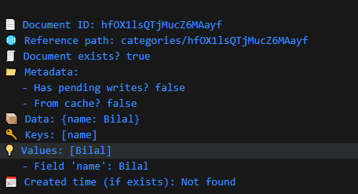
1️⃣ element.data()
Map<String, dynamic> data = element.data();
🔹 What it is:
- element.data() returns a Map where:
  - Keys (String) → the field names in your Firestore document.
  - Values (dynamic) → the field values, which can be:
    - String → e.g., "Fruits"
    - int → e.g., 5
    - double → e.g., 3.14
    - bool → e.g., true
    - Timestamp → Firestore timestamp
    - List → array of values
    - Map<String, dynamic> → nested map
    - GeoPoint → latitude/longitude
    - DocumentReference → reference to another document
    - null → empty field
🔹 Why dynamic?
- Because Firestore documents can store any type of value, not just strings or numbers.
- dynamic allows your code to accept all possible Firestore types without type errors.
For our app , we make like this :
List<String> categories = [];
getCategory() async {
await FirebaseFirestore.instance
.collection("categories")
.get()
.then((value) {
print("✅ Total documents found: ${value.docs.length}");
print(value.docs); // returns all docs as querySnapshot

for (var element in value.docs) {
categories.add(element.data()['name']);
}
})
.catchError((error) {
print("❌ Error getting categories: $error");
});
print(categories);
}

The things are sooo easy but the problem was how to refresh home after adding a new category , because getcategory function runs only in inistate , so it runs one time
So let learn some imporant things:
So the next lesson will be Routes listen
Now we will se onther simple solution :
Navigator.pushNamedAndRemoveUntil(
context,
'/home',
(_) => false,
);
This is the magic line, because now you will force initState() to run again. Normally, popping a page doesn’t re-call initState() since the widget already exists. Using this forces Flutter to recreate the page, so all initializations like fetching data happen again.

Routes listen
I showed you the solution but this is soooo usefull , really :
1️⃣ What is RouteObserver?
- RouteObserver is a Flutter class that observes navigation changes.
- It lets a page know when it comes back into view (for example, after another page is popped).
In the main :
Do this before main func
final RouteObserver<PageRoute> routeObserver = RouteObserver<PageRoute>();
then attach it to the MaterialApp :
navigatorObservers: [routeObserver], // ✅ attach observer
routes: {

2️⃣ What is RouteAware?
RouteAware is a tool provided by Flutter that allows a page to be aware of changes in the navigation stack. In other words, it helps a page know when it becomes visible or hidden because of navigation events, like when you go to another page or return back.
You attach it to your page using the with keyword:
class HomePageState extends State<HomePage> with RouteAware {
With RouteAware, your page can detect important events:
- didPush → the page was pushed onto the navigation stack.
- didPop → the page was popped (removed) from the stack.
- didPopNext → another page above this one was popped, so this page is now visible again.
- didPushNext → a new page was pushed on top of this one, so this page is now covered.

3️⃣ What is subscribe()?
The subscribe() method is how a page tells a RouteObserver:
“I want to listen to navigation events for this route.”
routeObserver.subscribe(this, ModalRoute.of(context)! as PageRoute);
Parameters explained
- this → The object that wants to listen. Usually the State of your page. Must implement RouteAware so it can receive callbacks like didPopNext().
- ModalRoute.of(context)! as PageRoute → The current route of this page. This tells the RouteObserver which route this subscription belongs to, so it can send notifications to the right page.

4️⃣ What is didChangeDependencies()?
- It’s a method in a StatefulWidget’s State.
- It runs after initState() and anytime the widget’s dependencies change.
- You use it when you need a ready context, for example to get the current route.
- It’s the right place to subscribe to a RouteObserver because context is safe to use here.
✅ In simple words:
didChangeDependencies() = “The widget is ready and its context is available. Time to subscribe to route changes or access inherited widgets.”
In simple words:
Dependencies = things outside your widget that your widget needs.
didChangeDependencies() runs when these things change or when the widget is first inserted in the tree.
Firestore : Delete
Now we will learn, how to delete
await FirebaseFirestore.instance
.collection('categories')
.doc(id)
.delete();

Now we will make a great revesion and we will deeply understand, what they are :

Revesion
🧩 1️⃣ FirebaseFirestore.instance
After typing FirebaseFirestore.instance. you’ll see options like 👇
Option | Type | Description
collection(path) | → CollectionReference | Access a collection (like a table).
collectionGroup(path) | → Query | Query across all subcollections with the same name.
batch() | → WriteBatch | Write/delete multiple docs at once.
runTransaction(fn) | → Future | Perform atomic reads/writes safely.
clearPersistence() | → Future<void> | Clear local cached data.
disableNetwork() | → Future<void> | Turn off Firestore’s online sync temporarily.
enableNetwork() | → Future<void> | Turn Firestore back online.
terminate() | → Future<void> | Stop Firestore completely (rarely used).
settings | FirebaseFirestoreSettings | Read Firestore settings.
useFirestoreEmulator(host, port) | → void | Connect to local emulator instead of cloud.

🧩 2️⃣ .collection('categories')
After .collection('categories'). you get CollectionReference options:
Option | Type | Description
add(data) | → Future<DocumentReference> | Add a new doc with auto-generated ID.
doc([id]) | → DocumentReference | Get reference to a specific document (if no id, Firestore generates one).
get() | → Future<QuerySnapshot> | Get all docs in the collection once.
snapshots() | → Stream<QuerySnapshot> | Listen to real-time updates.
where(field, …) | → Query | Filter docs by condition.
orderBy(field) | → Query | Sort docs by a field.
limit(number) | → Query | Limit how many docs you get.
startAt / endAt / startAfter / endBefore | → Query | Pagination control.
parent | → DocumentReference? | The parent doc if it’s a subcollection.
id | → String | The collection name.

Example :
final categories = FirebaseFirestore.instance.collection('categories');

// Add new doc
await categories.add({'name': 'Electronics'});

// Get all docs
final snapshot = await categories.get();
snapshot.docs.forEach((d) => print(d.data()));

// Listen to live changes
categories.snapshots().listen((event) {
print('Collection changed!');
});

🧩 3️⃣ .doc(id)
After .doc(id). you get DocumentReference options:
Option | Type | Description
set(data, [options]) | → Future<void> | Create or overwrite document.
update(data) | → Future<void> | Update only given fields.
delete() | → Future<void> | Delete the document.
get() | → Future<DocumentSnapshot> | Get doc data once.
snapshots() | → Stream<DocumentSnapshot> | Listen for real-time updates.
collection(subPath) | → CollectionReference | Access a subcollection.
id | → String | The document ID.
path | → String | Full Firestore path to the document.
parent | → CollectionReference | The parent collection.

Example :
final doc = FirebaseFirestore.instance.collection('categories').doc('abc');
// read
final snap = await doc.get();
print(snap.data());
// update
await doc.update({'name': 'Updated name'});

// listen live
doc.snapshots().listen((snapshot) {
print('Doc changed: ${snapshot.data()}');
});

🧩 4️⃣ .get() or .snapshots() return values
When you call | You get | Description
collection.get() | QuerySnapshot | Contains all QueryDocumentSnapshots.
doc.get() | DocumentSnapshot | Single document data.
collection.snapshots() | Stream<QuerySnapshot> | Stream that updates when data changes.
doc.snapshots() | Stream<DocumentSnapshot> | Real-time updates for one document.

🧩 5️⃣ .batch() options (optional but powerful)
If you do FirebaseFirestore.instance.batch(), you can then call:
Option | Description
set(documentRef, data) | Add or replace doc.
update(documentRef, data) | Update doc fields.
delete(documentRef) | Delete doc.
commit() | Execute all writes together.

Example :

final batch = FirebaseFirestore.instance.batch();
final col = FirebaseFirestore.instance.collection('categories');

batch.set(col.doc('1'), {'name': 'Phones'});
batch.update(col.doc('2'), {'name': 'Laptops'});
batch.delete(col.doc('3'));

await batch.commit();
---------------------fin de révison + plein d’info
f

Logical Thinking
In this part we will learn , how user1 can see only his folder and not his folders and others users’s folders , okay so let’s get started :
So the idea is : when adding a doc , we will add its name and the id of user that create it , so when fetching data for a user(id1) we will get doc that only containd id: id1 , so that is the idea .
Adding :
Future<void> addCategory(String data) {
return categories
.add({'name': data, 'uid': FirebaseAuth.instance.currentUser!.uid})
.then((value) => print("Category Added"))
.catchError((error) => print(error));
}
Fetching :
QuerySnapshot value = await FirebaseFirestore.instance
.collection("categories")
.where("uid", isEqualTo: FirebaseAuth.instance.currentUser!.uid)
.get();
Firestore Update
This is my update file :
class updateCategory extends StatefulWidget {
String oldName;
String? id;
updateCategory({super.key, required this.id, required this.oldName});

@override
State<updateCategory> createState() => _UpdateCategoryState();
}

class _UpdateCategoryState extends State<updateCategory> {
CollectionReference categories = FirebaseFirestore.instance.collection(
"categories",
);

Future<void> updateCategory() async {
await categories.doc(widget.id).update({'name': controller.text});
}

// Form Key
GlobalKey<FormState> formKey = GlobalKey<FormState>();
TextEditingController controller = TextEditingController();

@override
void initState() {
super.initState();
controller.text = widget.oldName;
}

@override
Widget build(BuildContext context) {
return Scaffold(
appBar: AppBar(title: const Text("Update Category")),
body: Center(
child: Container(
padding: const EdgeInsets.all(20),
height: 300,
child: Form(
key: formKey,
child: Column(
children: [
CustomTextField(
// filed contain old value
validator: (value) {
if (value!.isEmpty) {
print("Empty");
return "Please Enter The New Category Name";
}
return null;
},
controller: controller,
),
SizedBox(height: 20),
mainButton(
text: "Update",
onPressed: () async {
if (formKey.currentState!.validate()) {
try {
await updateCategory();
print("Category Updated");
// snackbar to show success message
ScaffoldMessenger.of(context).showSnackBar(
const SnackBar(
content: Text("Category Updated Successfully!"),
backgroundColor: Colors.green,
duration: Duration(seconds: 2),
// success
behavior: SnackBarBehavior.floating,
),
);
Navigator.pushNamedAndRemoveUntil(
context,
'/home',
(_) => false,
);
} catch (e) {
print(e);
}
}
},
),
],
),
),
),
),
);
}
}

You write widget.id or widget.oldName because:
- id and oldName are defined in the widget, not in the state.
- The state class can access its widget’s variables using the widget keyword.

🧠 Think of it like this:
- updateCategory = the “container” (the widget itself).
- _updateCategoryState = the “brain” that controls what happens inside.
The “brain” doesn’t own the widget’s data directly, but it can look inside it using widget.

🧍‍♂️Simple analogy:
If updateCategory is a person and id is their ID card,
then _updateCategoryState is their brain — it can see the ID card by saying “my widget.id”.

Firestore Set
🧩 What is set() in Firestore?
set() is a method used to create or replace a document in a Firestore collection.
It’s like saying:
“Put this data in this document — if it exists, replace it; if not, create it.”
🧠 Example:
FirebaseFirestore.instance
.collection('users')
.doc('user1')
.set({'name': 'Bilal', 'age': 21});
👉 This will create a document with ID user1 in the users collection.
If user1 already exists, it will replace all its data with { name: 'Bilal', age: 21 }.
FireStore Subcollections
🧩 What is a Subcollection in Firestore?
A subcollection is a collection inside a document.
It helps you organize your data in a tree-like (hierarchical) structure.
🧠 Example structure
users (collection)
└── user1 (document)
└── orders (subcollection)
└── order1 (document)
└── order2 (document)
So:
- users is the main collection
- user1 is a document
- orders is a subcollection that belongs to user1
🧠 Key idea
In Firestore:
- Every document can contain subcollections.
- Each subcollection can contain documents,
- and those documents can again have their own subcollections.
This can go many levels deep.
🔁 Hierarchy example:
users
└── user1
└── posts
└── post1
└── comments
└── comment1

Compatibily :
1️⃣ Flutter ↔ Dart
- Flutter version determines Dart version.
- Rule: Use the Dart bundled with your Flutter version.
- Example: Flutter 3.13 → Dart 3.1.x
- ✅ You don’t choose Dart separately, Flutter manages it.

Firestore Subcollections : add

Firestore Subcollections : update

Firestore Subcollections : delete

Firestore Filtering Part 1

Firestore Filtering Part 2

